ENEL599 Final Project Changelog

# Premise

I decided to make a pong gaming system using an LED display panel. The Arduino will output its display to a 32x16 p10-8s RGB LED panel. Player input can be gathered using two potentiometers which map their turn range to the paddle position for that player. Scored should be output to two 7-segment displays. A speaker or buzzer should beep when the ball hits a panel or goes out of bounds.

## Parts list

* RGB LED Panel P10-8s
* Arduino nano for panel driving
* Second Arduino for game simulation, player IO.
* 2x 7-segment display
* Shift register
* 5V 20W power supply.
* 2x 10kr Potentiometers with knobs

## Panel Driver Prototyping

After attempting to interact with the shift-registers in the display panel I decided that I would not have enough time to write my own driver code at this stage. I decided to use the Adafruit LEDMatrix library to drive the panel.

My initial prototype used a breadboard to connect the Arduino to the LED panel but encountering some instability issues I decided to move this section to a soldered prototyping board to eliminate inconsistent connections.

I ran a test to check if the line-select wires were incorrectly connected by lighting up each row of the display in order. I noticed some lines lighting up in the incorrect order so I swapped the line select pins in software, this resolves my image distortion.

## 7-Segent Display Prototyping

To display the scores, I wanted to use 7-segment displays driven by shift registers to minimize pin use on my Arduino. Using a second Arduino I wired up two displays, one for each shift register and chained the registers together.

After correcting some misplaced wires, I was able to display numbers on the displays by mapping segment on/off states to bits in a byte and shifting this byte out into the registers.

## PCB Design

To integrate my two prototypes into a cohesive system, I decided to design and order a PCB. I designed a schematic in KiCAD and then imported the nets into the KiCAD PCB designer. After making all connections and ensuring the design passed DRC I sent the files to JLCPCB for manufacturing.

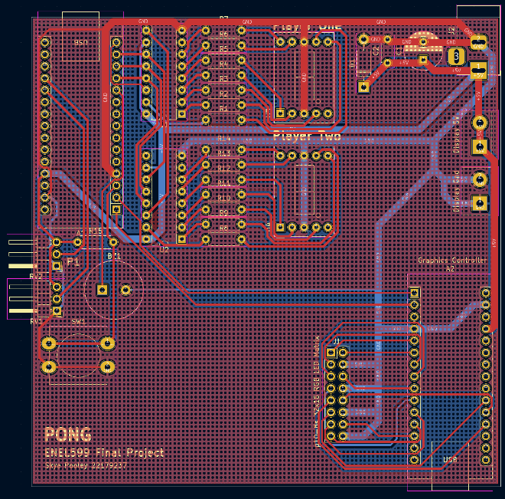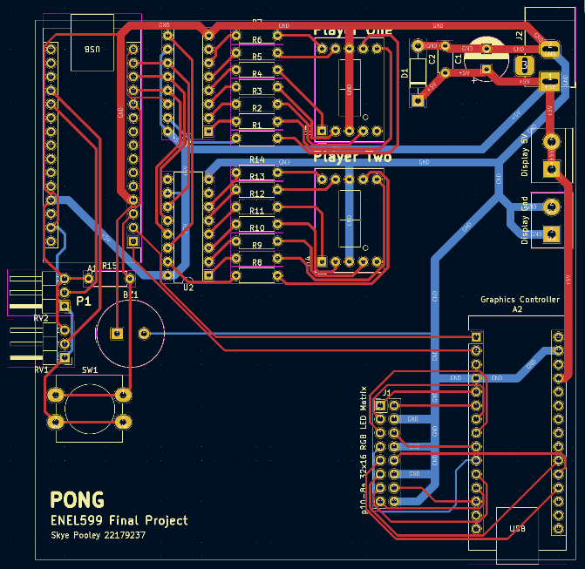

*PCB Design shown with and without ground fills visible.*

*Schematic.*

The PCB design connects the two Arduinos via serial so that one can handle display rendering driving while it receives information on entity positioning via serial from the other Arduino which handles IO.

*Send the graphics instructions by bithacking the flag into the value!*

Numbers to transmit:

1. Paddle A position – 0-15 (4 bits)
2. Paddle B position – 0-15
3. Ball horizontal pos – 0-31 (5 bits)
4. Ball vertical pos = 0-15

We will need 5 bits to transmit the value of each number leaving three bits for the flag.

Three flag bits gives us 8 possible flags, more than currently needed.